# Real-Valued Optimization Using Evolution Strategies

*Date: 6-12-2013*

*Authors:*

*Brian Weeteling* [*brian_weeteling@hotmail.com*](mailto:brian_weeteling@hotmail.com) *1276417*

*Ricardo Blikman* [*ricardo.blikman@yahoo.com*](mailto:ricardo.blikman@yahoo.com) *1184164*

# *Universiteit Leiden*

# 

# Introduction

In this research assignment we must implement an evolutionary strategy in MATLAB and benchmark it against five black-boxoptimization problems that are given to us. The algorithm should also be able to operate on arbitrary values of µ and $λ$. Each black-box problem consists of a function with real-valued input parameters that is to be minimized:

$$f\left(x\right)→min, x in {R }^{n}$$

Subject to $-100< x_{i}<100$ for all $i$ in $\{ 1,…, N\}$

with $N$ = 30 (i.e., a 30-dimensional search space).

# Problem Description

Our research question is: How well does our implementation of an evolutionary algorithm perform based on five black-box benchmarks for real-valued optimization?

# Method

We will implement both 1+1 and $μ,λ$ evolution strategies in MATLAB and benchmark both implementations and compare them based on a budget of 10,000 function evaluations per run averaged over 20 runs over each of the five black-box problems to answer our research question. We will also set different values for both $μ$ and $λ$.

# Implementation

We have implemented a Genetic Algorithm in MATLAB with the following signature:

function [aopt, fopt] = weeteling_blikman_es(cnf_file, eval_budget)

The following parameters must be supplied:

cnf_file (Benchmark), eval_budget (evauluations to be made)

## Pseudo code $μ, λ$ Implementation

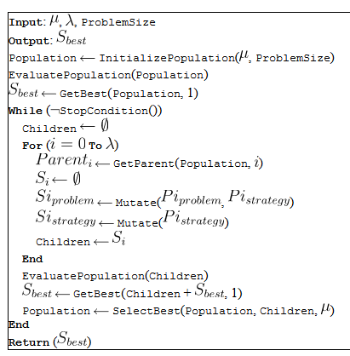

Input: Objective function, dimensions, lower bound, upper bound.

Output: population, Best, statistics.

Set $μ$

Set $λ$

Population 🡨 (dimensions, $μ$, lower bound, upper bound)

Initialize sigma (lower bound + (upperboud - lowerbound) * random($μ$)) /6

EvaluatePopulation(Population)

Best = Getbest(Population)

While evaluations < stopval

‘ $τ= \frac{1}{\sqrt{2n}}$

For I = 1 to $λ$

$$τ= \frac{1}{\sqrt{2\sqrt{n}}}$$

## Variables

Our algorithm starts with initializing the following variables:

$μ$ = 3 (Parents)

$λ$ = 12 (Offspring)

And in another run:

$μ$ = 15 (Parents)

$λ$ = 100 (Offspring)

## Initialization

We start with initializing a random vector of bits based on the size provided by the parameter: cnf_file (benchmark file) and initialize the population of the vector for $μ$ mutations. We Generate random chromosome, decode to phenotype, and evaluate these using the feval function in MATLAB.

## Evolution

For $μ$ evolutions we generate new population. We start with evaluating P1 (parent one) using the feval function based on the tournament parameters. Then we evaluate the chance of $P_{c}$ to occur by using a random number. If $P_{c}$ occurs then we create a second parent P2 using the same function and parameters as P1 and create a child based on P1|P2 and complete our crossover. If $P_{c}$ does not occur we copy the parent into our new generation.

mutationString = rand(n,1) < pm;

mutatedIndividual = xor(Pnew(:,i),mutationString);

Pnew(:,i) = mutatedIndividual;

% Decode and evaluate

for i = 1:mu

g(:,i) = feval(decodefct, P(:,i));

f(i) = feval(fitnessfct, g(:,i));

end

%save best from last generation

[~, worstindex] = min(f);

P(:,worstindex) = aopt;

f(worstindex) = fopt;

% Statistics administration

[fopt, optindex] = max(f);

aopt = P(:,optindex);

for i = 1:mu

evalcount = evalcount + 1;

% histf(evalcount) = fopt;

end

after each evaluation we set the permutation rate (pm) to: -.985+exp((0.5+(1-currentEvaluation)/(functionEvaluations *2.5))^4).

# Experiments

We benchmarked our implementations based on a budget of 10,000 function evaluations per run averaged over 20 runs over each of the five black-box problems given to us.

We benchmarked our implementation against 10 benchmarks problems for a MAX-3SAT problem with a maximum of 10,000 function evaluations per run averaged over 20 runs. The following benchmarks where used:

|  |  |
| --- | --- |
| Benchmark 1 | bbf1.m |
| Benchmark 2 | bbf2.m |
| Benchmark 3 | bbf3.m |
| Benchmark 4 | bbf4.m |
| Benchmark 5 | bbf5.m |

We have set two different values for both $μ$ and $λ$. Our initial run with the $μ,λ$ was:

$μ$ = 3 and $λ$ =12

In our second run for the $μ,λ$ strategy we set the values to:

$μ$ = 15 and $λ$ = 100.

Our experiment yielded the following results:

|  |  |  |  |  |  |  |  |  |
| --- | --- | --- | --- | --- | --- | --- | --- | --- |
| BBF1 |  |  |  |  |  |  |  |  |
| Function | At 1000 eval | | | | At 10000 eval | | | |
|  | min | max | mean | std | min | max | mean | std |
| 3,12 | 55,1034 | 2569,994 | 447,013 | 707,4673 | 34,5575 | 34,5575 | 34,5575 | 7,11E-15 |
| 15,100 | 1646,152 | 18386,47 | 6640,775 | 4102,271 | 34,5576 | 34,5786 | 34,5608 | 0,005647 |
| 1+1 | 34,8757 | 77,1629 | 43,0728 | 11,0562 | 34,5575 | 34,5575 | 34,5575 | 1,41E-14 |
|  |  |  |  |  |  |  |  |  |
| BBF2 |  |  |  |  |  |  |  |  |
|  | At 1000 eval | | | | At 10000 eval | | | |
| Function | min | max | mean | std | min | max | mean | std |
| 3,12 | 1418,459 | 16474,18 | 6727,592 | 4623,319 | 220,7705 | 4753,914 | 868,8151 | 1042,451 |
| 15,100 | 82291,32 | 302314,3 | 181840,9 | 54791,05 | 316,3063 | 580,4581 | 428,2092 | 80,0053 |
| 1+1 | 447,1914 | 3094,793 | 917,385 | 550,1389 | 297,3813 | 1004,764 | 585,5591 | 209,0616 |
|  |  |  |  |  |  |  |  |  |
| BBF3 |  |  |  |  |  |  |  |  |
| Function | At 1000 eval | | | | At 10000 eval | | | |
|  | min | max | mean | std | min | max | mean | std |
| 3,12 | 4728,607 | 637261,6 | 123439,7 | 192594,4 | 40,8964 | 52,5223 | 42,8068 | 3,095 |
| 15,100 | 686003,4 | 14680687 | 4916420 | 4260836 | 65,1672 | 2163,664 | 763,8674 | 678,6048 |
| 1+1 | 89,9708 | 7931,828 | 1108,556 | 1811,72 | 40,8407 | 311,5456 | 120,6188 | 92,5931 |
|  |  |  |  |  |  |  |  |  |
| BBF4 |  |  |  |  |  |  |  |  |
| Function | At 1000 eval | | | | At 10000 eval | | | |
|  | min | max | mean | std | min | max | mean | std |
| 3,12 | 45,0284 | 46,5566 | 45,3208 | 0,36001 | 43,9823 | 44,0193 | 43,9964 | 0,012371 |
| 15,100 | 46,6346 | 55,7886 | 49,9422 | 2,7921 | 44,1291 | 44,5433 | 44,3026 | 0,11315 |
| 1+1 | 44,1427 | 45,0376 | 44,7143 | 0,27313 | 43,9823 | 44,0289 | 43,9926 | 0,012536 |
|  |  |  |  |  |  |  |  |  |
| BBF5 |  |  |  |  |  |  |  |  |
| Function | At 1000 eval | | | | At 10000 eval | | | |
|  | min | max | mean | std | min | max | mean | std |
| 3,12 | 68,3066 | 68,7698 | 68,6043 | 0,10064 | 68,2853 | 68,7565 | 68,6155 | 0,10908 |
| 15,100 | 67,4522 | 68,5608 | 68,334 | 0,28681 | 50,941 | 68,5782 | 64,7729 | 6,2686 |
| 1+1 | 67,1249 | 67,3662 | 67,2137 | 0,074606 | 67,1236 | 67,1239 | 67,1238 | 7,94E-05 |

Table 1: Final solution(s) quality after 10,000 function evaluations, averaged over 20 runs

Benchmark results:

# C:\Studie\Computer Science\EA\Assignment2\Final matlab\Result images\bbf1.png

Figure 1: bbf1 benchmark.

# C:\Studie\Computer Science\EA\Assignment2\Final matlab\Result images\bbf2.png

Figure 2: bbf2 benchmark.

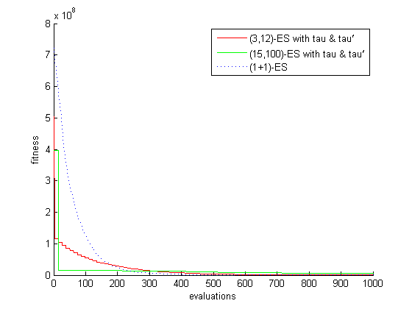

Figure 3: bbf1 benchmark.

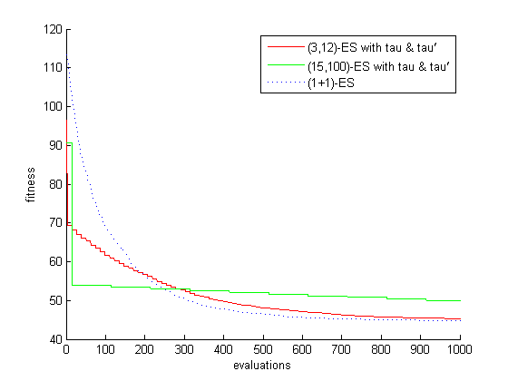

Figure 4: bbf4 benchmark.

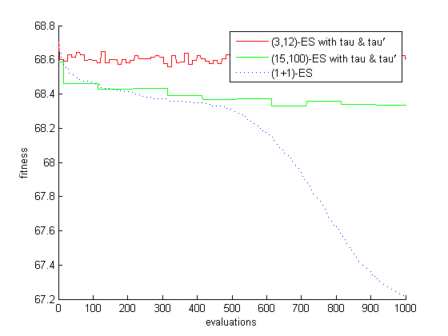

Figure 5: bbf5 benchmark.

# Discussion and Conclusion

The goal of this research assignment was to measure how well does our implementation of an evolutionary algorithm perform based on five black-box benchmarks for real-valued optimization?

Based on the outcome of this experiment we can conclude the following:

The black-box functions are probably functions picked from different problem classes, there is not one algorithm that can be picked as clear winner on all functions. The 1+1 ES has the best overall results though, with 10000 function evaluation but especially considering the results at 1000 evaluations. Since we are limited to $μ,λ$ strategies we would pick the 3,12 ES as winner, with the 15,100 as a close second. The 3,12 ES seems to be especially fit for black-box function 3, as it is a clear winner on all measurements.

Another interesting observation is that the 15,100 ES converges very fast on the first 20-30 function evaluations. So when the evaluation budget is very low, we could definitely propose the 15,100 ES as best solution.